LAB # 7

**OBJECTIVE:** To learn RMI-IIOP

**Task:** Write the code for matrix multiplication and divide the code into four threads. Also note the timestamp at the start and end of the program. Give your conclusion.

**Code: -**

class Thread1 extends Thread{

int[][] a;

int[][] b;

int[] c = new int[3];

public Thread1(int[][] a, int[][] b){

this.a = a;

this.b = b;

}

public void run(){

System.out.println("First thread is running...");

//Multiplying first row

for(int i = 0; i < 1; i++){

for(int j = 0; j < 3; j++){

int sum = 0;

for(int k = 0; k < 3; k++){

sum = sum + a[i][k] * b[k][j];

}

c[j] = sum;

}

}

System.out.println("First thread completed.");

}

}

class Thread2 extends Thread{

int[][] a;

int[][] b;

int[] c = new int[3];

public Thread2(int[][] a, int[][] b){

this.a = a;

this.b = b;

}

public void run(){

System.out.println("Second thread is running...");

//Multiplying second row

for(int i = 1; i <= 1; i++){

for(int j = 0; j < 3; j++){

int sum = 0;

for(int k = 0; k < 3; k++){

sum = sum + a[i][k] * b[k][j];

}

c[j] = sum;

}

}

System.out.println("Second thread completed.");

}

}

class Thread3 extends Thread{

int[][] a;

int[][] b;

int[] c = new int[3];

public Thread3(int[][] a, int[][] b){

this.a = a;

this.b = b;

}

public void run(){

System.out.println("Third thread is running...");

//Multiplying third row

for(int i = 2; i <= 2; i++){

for(int j = 0; j < 3; j++){

int sum = 0;

for(int k = 0; k < 3; k++){

sum = sum + a[i][k] * b[k][j];

}

c[j] = sum;

}

}

System.out.println("Third thread completed.");

}

}

class MatrixMultiplyThread{

public static void main(String[] args){

int[][] a = {{4,5,6},{7,8,9},{1,2,3}};

int[][] b = {{1,8,9},{7,3,2},{5,6,5}};

System.out.println("Main thread is runnning...");

long start = System.currentTimeMillis();

Thread1 t1 = new Thread1(a, b);

t1.start();

Thread2 t2 = new Thread2(a, b);

t2.start();

Thread3 t3 = new Thread3(a, b);

t3.start();

System.out.println("Main thread completed.");

while(t1.isAlive() || t2.isAlive() || t3.isAlive()){}

long end = System.currentTimeMillis();

System.out.println();

for(int i = 0; i < t1.c.length; i++){

System.out.print(t1.c[i]+" ");

}

System.out.println();

for(int i = 0; i < t2.c.length; i++){

System.out.print(t2.c[i]+" ");

}

System.out.println();

for(int i = 0; i < t3.c.length; i++){

System.out.print(t3.c[i]+" ");

}

System.out.println("\n\nRuntime = " + (end - start) + "ms");

}

}

**Output:-**

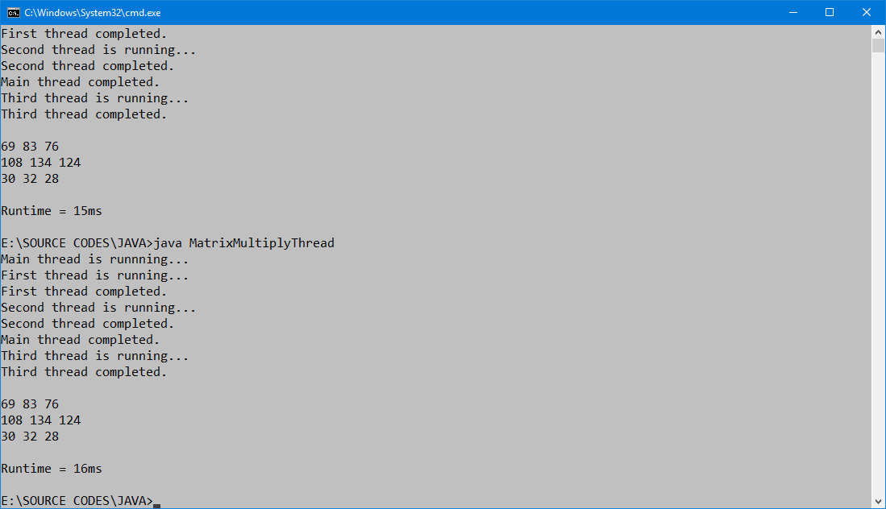

The program is taking very short time to execute four threads, we can’t measure this amount of time on the scale of seconds. We have to measure the runtime on the scale of milliseconds. The program is taking 16-15 milliseconds to complete four threads to multiply two matrices.